Erika Parayno
February 26, 2020
CSS 501 B
Program 4: Design

Overview: This program utilizes what we learned about SearchTrees, lists, HashTables, pointers, dynamic allocation of data to create a Collectibles Store system.

The system contains primarily two databases, one of the Customers and one of the Items, both of which are implemented with Binary Search Trees. They are implemented with Binary Search Trees due to their relatively efficient traversals and ability to keep a sorted structure.

The program is initialized by reading data from a local text file and creates the two search trees. It also creates a HashTable which will be used as a lookup table, to take advantage of HashTable’s O(1) efficiency.

The structures will utilize a Comparable class which is a base class, so that we can use both HashMap and SearchTree with different data.

Customers are relatively simple as they do not include derived classes. However, they do contain a vector to store customer’s transaction history. We are using a LinkedList in this case as we will always add the end and traverse from the beginning, make it a relatively simple structure to implement.

In this Collectibles store, we keep in hand three different items. Because they are all items and share some characteristics, I decided to implement them as derived classes of Item. This allows for all three items to be stored in the same SearchTree inventory.

Once all data has been initialized, we can now run the commands, which is also a text file from the directory. This will utilizes many different actions in the InventoryTracker. Any changes will be logged and data sets will be updated accordingly.

UML Diagrams
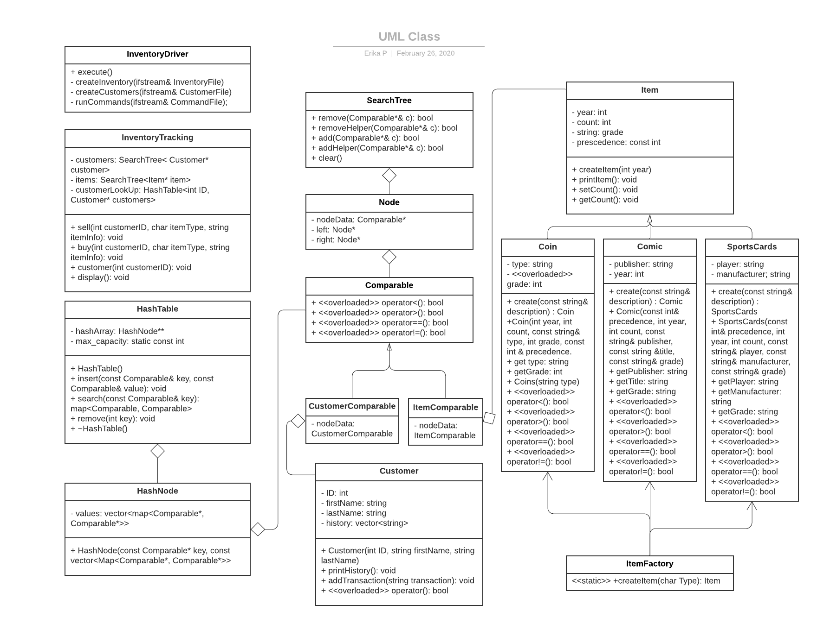

Memory Diagrams
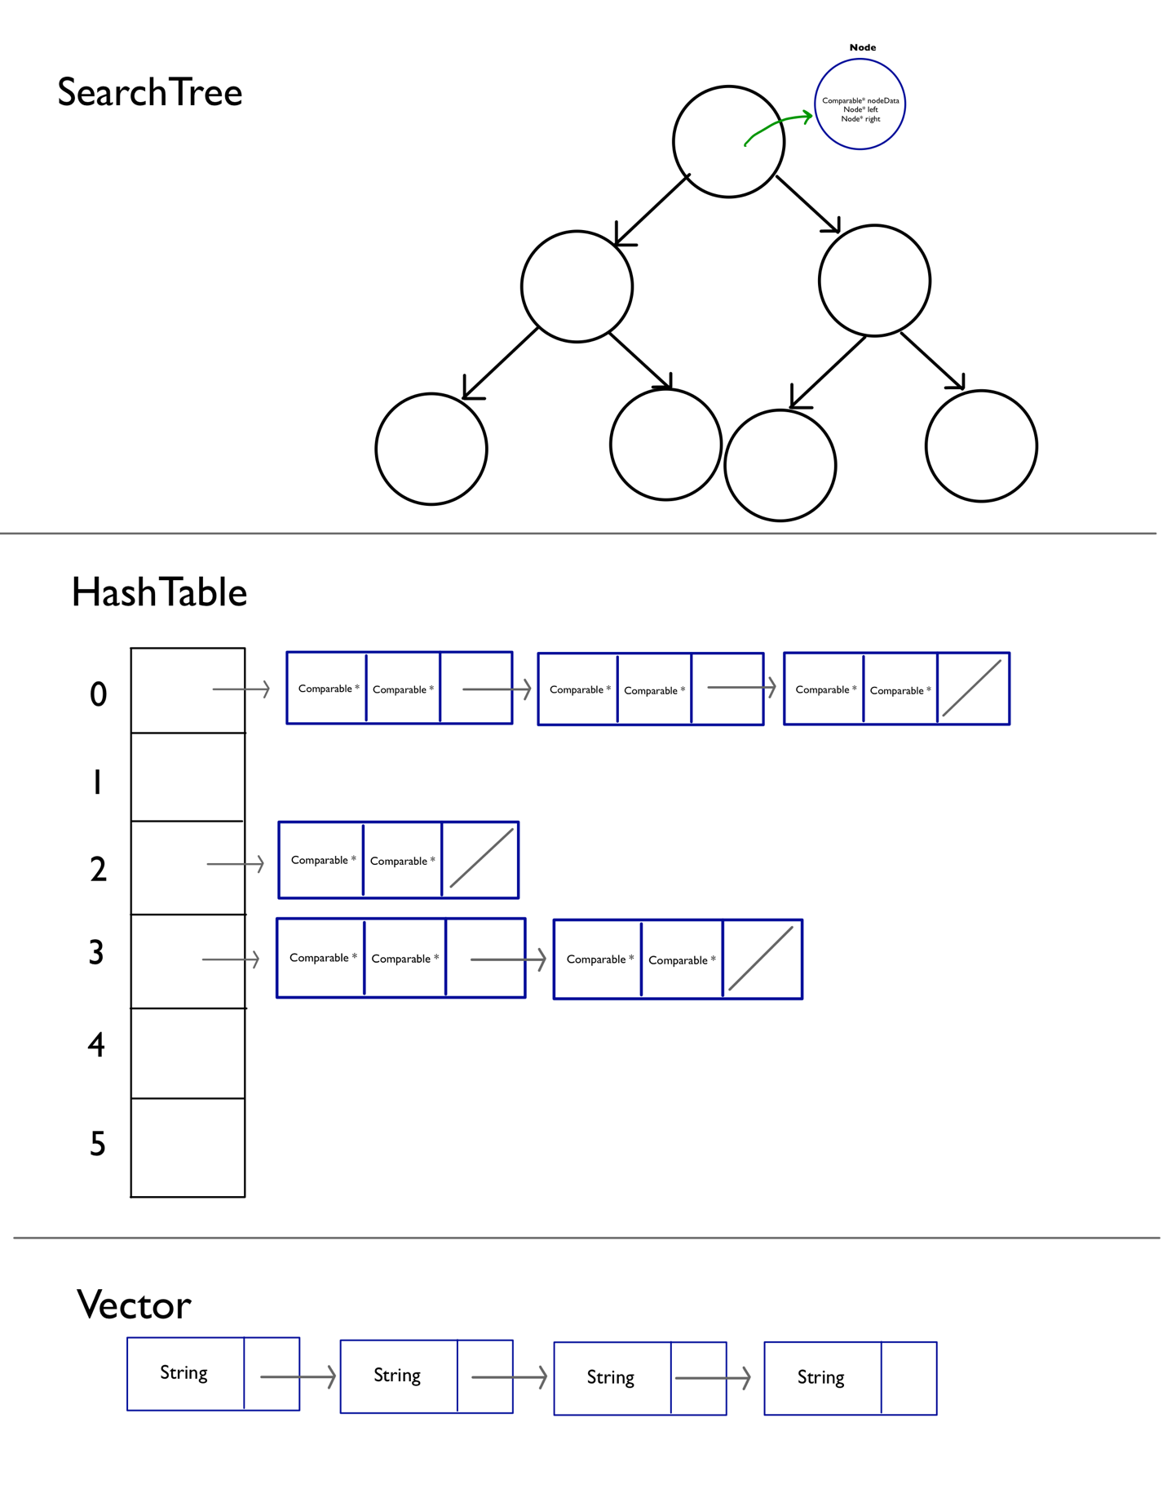

Class descriptions:

/* ---------------------------------------------------------------------------
SPORTSCARD.H
Item data structure
Authors: Erika Parayno
---------------------------------------------------------------------------
SportsCard class: This class is a derived item class. It is a SportsCard class
that also contains player, manufacturer, and grade information in addition to
base class, Item.
-- Sets precedence to 2
-- includes necessary getters and modifiers
Assumptions:
-- Bool operators are based on the following ordering: player, year,
manufacturer, then grade, as defined in the program description. */

/* ---------------------------------------------------------------------------
SEARCHTREE.H
Binary Search Tree for Comparable
Authors: Erika Parayno
---------------------------------------------------------------------------
SearchTree class: Like a regular binary search tree (retains all
functionality but instead holds Node pointers, which contains Comparable pointer
responsible for encapsulating a char by default.
-- Contains default constructor, deep copy constructor, and destructor.
-- allows for retrieval, insertion, and removal of Comparable* item
Assumptions:
-- Follows properties of trees
-- Nodes and corresponding data initialized as null
-- user must use driver to utilize methods in SearchTree
-- in <<, each node will be represented by one line */

/* ---------------------------------------------------------------------------
MAIN.CPP
Main executable
Authors: Erika Parayno
---------------------------------------------------------------------------
Main class: This class is just used to create new InventoryDriver to run
execute.
-- Will call execute from InventoryDriver which will initialize
inventory data, customer data, and run commands. */

/* ---------------------------------------------------------------------------
ITEMFACTORY.H
ItemFactory class called used to create Item objects
Authors: Erika Parayno
---------------------------------------------------------------------------
ItemFactory class: This class allows for us to define member operations for
each of the derived Item classes and refer to it with a base class pointer.
-- One simple method to allow us to take advantage of the Open-Closed
principle.
Assumptions:
-- Assumes all derived item classes have their own create()
implementation */

/* ---------------------------------------------------------------------------
ITEMCOMPARABLE.H
Derived class of Comparable for Item data
Authors: Erika Parayno
---------------------------------------------------------------------------
SearchTree class: This class will encapsulate Item data structure.
-- Overloads nodeData, so it can use all functionality of Item class. */

/* ---------------------------------------------------------------------------
ITEM.H
Item data structure
Authors: Erika Parayno
---------------------------------------------------------------------------
Item class: This class is the base class for all items.
-- Sets precedence to -1 by default
-- includes necessary getters and modifiers
-- count initialized at 0
-- the bool operators will be based off precedence value (the lower the
value, the higher the precedence.
Assumptions:
-- Precedence is initialized based on ordering: Coin, Comic, SportsCard,
as defined in the program description. */

/* ---------------------------------------------------------------------------
INVENTORYTRACKER.H
Contains most actions for the class
Authors: Erika Parayno
---------------------------------------------------------------------------
InventoryTracker class: This class is called by driver and mostly used to
take in parameters and performs specific tasks with member variables
containing customer and item data
-- Sell and buy items, updating Customer and Item data accordingly
-- Perform print functions: items, customers, all customers
Assumptions:
-- Being called by driver*/

/* ---------------------------------------------------------------------------
INVENTORYDRIVER.H
InventoryDriver class called by main to execute program
Authors: Erika Parayno
---------------------------------------------------------------------------
Coin class: The main function of this class to extract data from text files
provided in the directory. The files contain initial inventory, customer
profiles, and a set commands to run.
-- Initializes inventory
-- Creates customer database
-- Runs commands
Assumptions:
-- Assumes all three files are present in the directory */

/* ---------------------------------------------------------------------------
HASHTABLE.H
HashTable implementation
Authors: Erika Parayno
---------------------------------------------------------------------------
HashTable class: An array implementation of HashTable. Utilizes vector as
value to deal with collisions.
-- Has a nested struct HashNode, which contains Comparable pointer.
-- Contains necessary constructor and destructor.
-- Implements insertion and removal.
Assumptions:
-- Assumes largest capacity size is 999 */

/* ---------------------------------------------------------------------------
CUSTOMERCOMPARABLE.H
Derived class of Comparable for Customer data
Authors: Erika Parayno
---------------------------------------------------------------------------
SearchTree class: This class will encapsulate Customer data structure.
-- Overloads nodeData, so it can use all functionality of Customer

/* ---------------------------------------------------------------------------
CUSTOMER.H
Customer data structure
Authors: Erika Parayno
---------------------------------------------------------------------------
Customer class: This class will contain all Customer information as
as well as the customer's transaction history.
-- Contains customer ID and name and list of history transaction
-- includes necessary getters and modifiers
Assumptions:
-- Initialized by InventoryDriver, where it reads customer data from
local text file . */

/* ---------------------------------------------------------------------------
COMPARABLE.H
Comparable class used in HashTable and SearchTree
Authors: Erika Parayno
---------------------------------------------------------------------------
Comparable class: This class is a base class for CustomerComparable and
ItemComparable. It is one of the members in the SearchTree class. Contains
header members.
-- checks for inequality and comparison, which will allow us to sort
tree in ascending order.
Assumptions:
-- Derived classes are contained in same directory
*/

/* ---------------------------------------------------------------------------
COMIC.H
Item data structure
Authors: Erika Parayno
---------------------------------------------------------------------------
Comic class: This class is a derived item class. It is a Comic class
that also contains title, publisher, and grade information in addition to
base class, Item.
-- Sets precedence to 1
-- includes necessary getters and modifiers
Assumptions:
-- Bool operators are based on the following ordering: publisher, title,
year, then grade, as defined in the program description. */

/* ---------------------------------------------------------------------------
COIN.H
Item data structure
Authors: Erika Parayno
---------------------------------------------------------------------------
Coin class: This class is a derived item class. It is a Coin class
that also contains type and grade information in addition to base class, Item.
-- Sets precedence to 0
-- includes necessary getters and modifiers
Assumptions:
-- Bool operators are based on the following ordering: type, year,
then grade, as defined in the program description. */

